**Stock Mega-Trades**

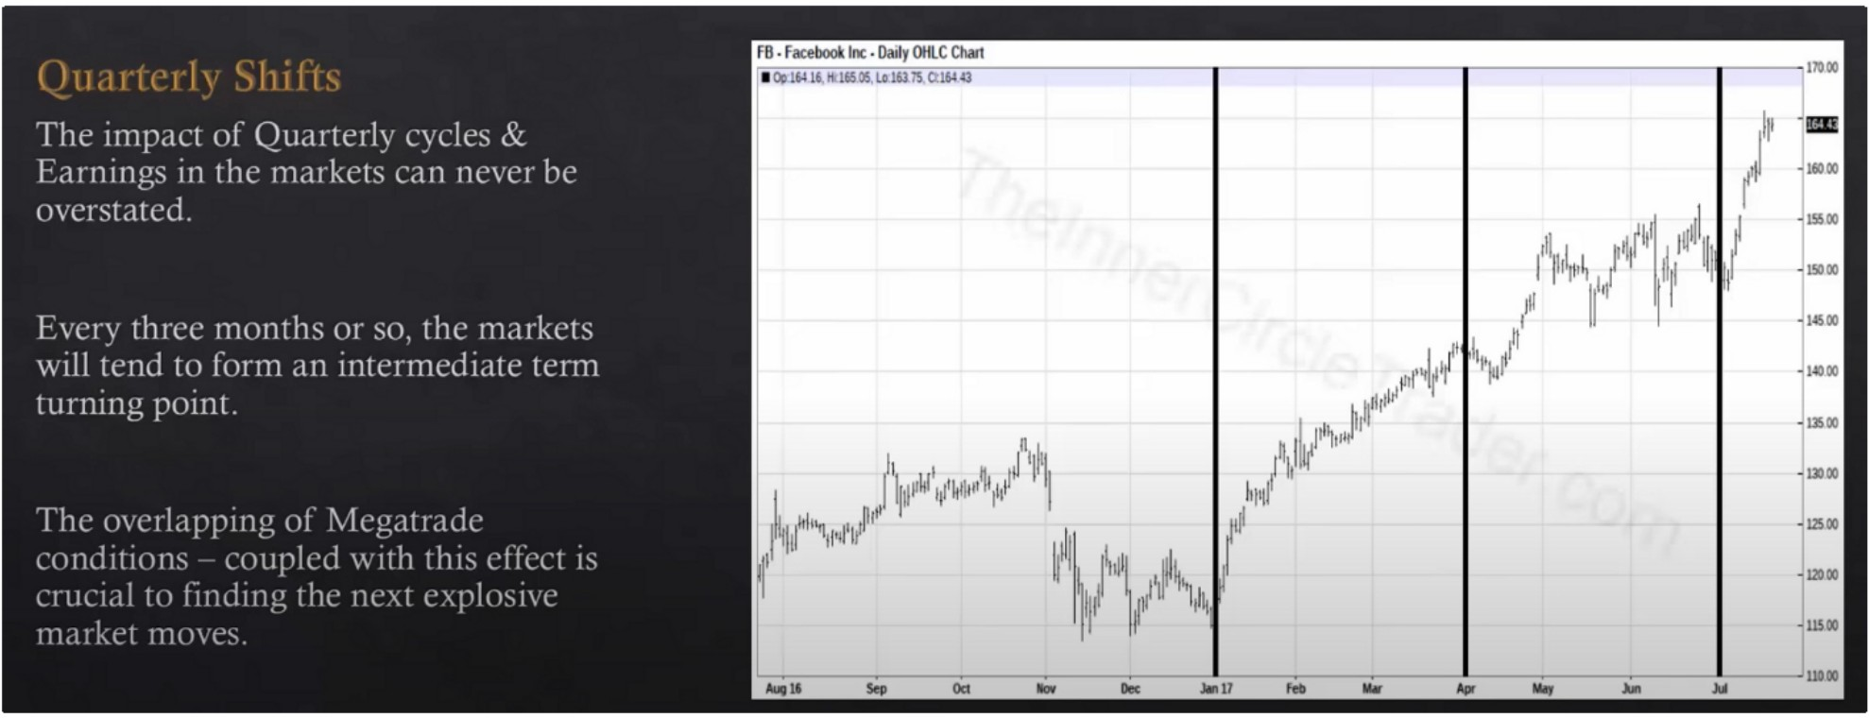

Quarterly shifts in stocks are closely related to earnings

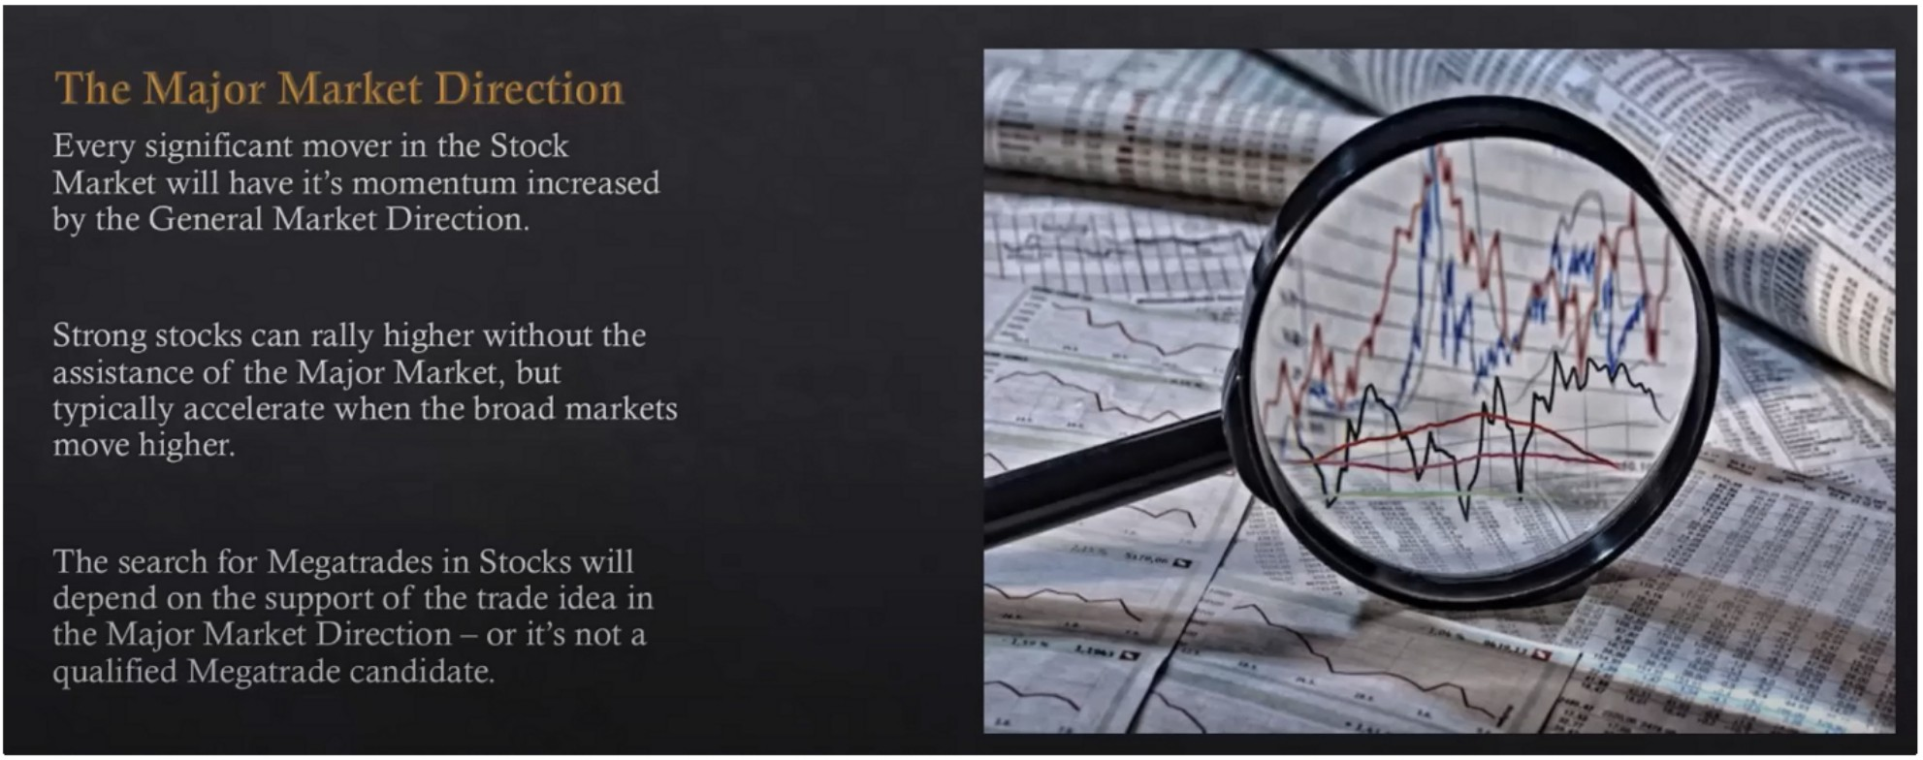

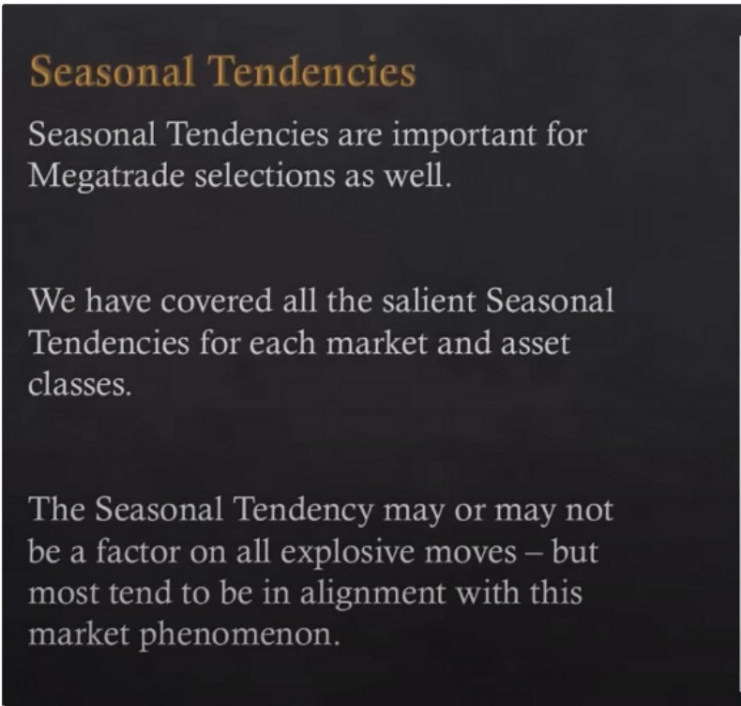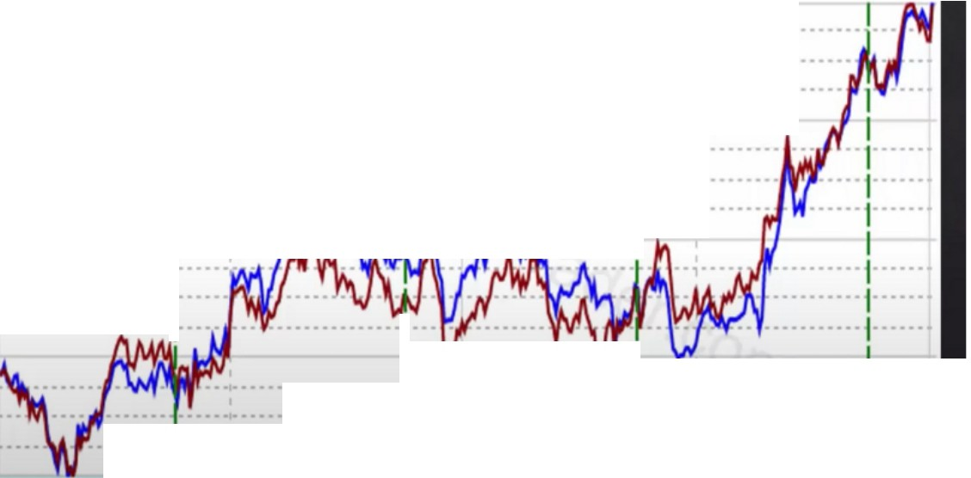

03 Jan 2017 I 20•Yr I lS•Yr I S•Yr

100

················I····················I·····················I·····•··········

··················1· **·· ··················1·····** .................. *�....:. ........*

75

I

:: :: :··: ::·:·::::·:

I

I

**····1··** ••••••••• ·: :.:: **1::** ::'.:

•••••••••• ·······1··· I

50

..................

,

I

I

I

I

I

25

I

I

.,...................,... ..... ··················1·······················1....

·············I···· ··················I I ••••

I

* ·····I I

I

I

I

I

Apr 2016 Jul Oct

Are NAS, DOW and SP moving up or dropping?

Mega trades are really aimed to buy, especially in stocks

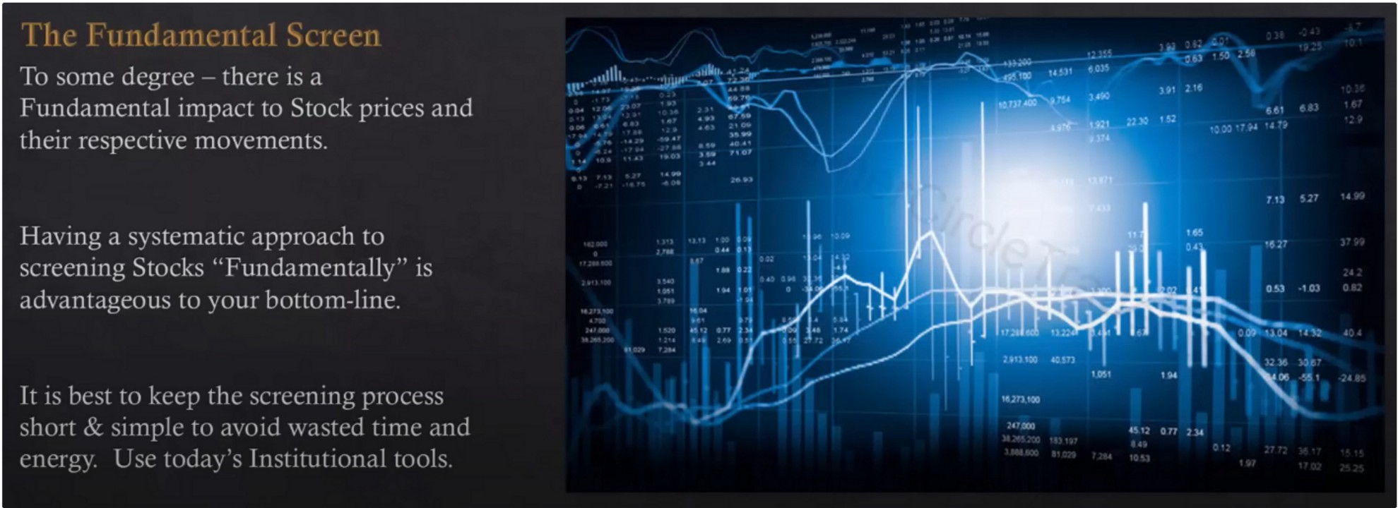

Keep it short and simple and use the tools available even if you have to invest some money for it, its worth it

Do the things yourself, you will do the best job at it

You want to do this all on your own, dont over complicate it

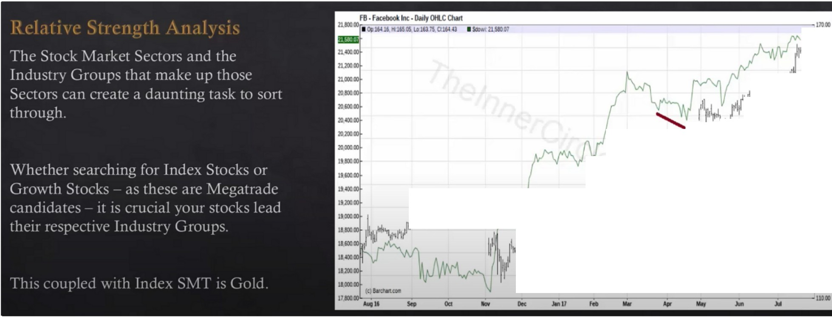

**·a**

**-ltollO**

I 1!11 I

1

i'" I

I

1111

.....

1i **·llO<O**

-,H

jI>l' l'f'J./1/ iliii" ._,.,,,,.

**·IU**

h ,, J

l\iJ1' 1i/W' 11il

l pl\,,,

:::

•

I/

1111

24 Dollar Move ::

Its better to trust a tool like IBD to filter the leaderships stocks, because theres so many sectors etc So you focus on the strongest of the strongest of the strongest during a bullish market, thats how you get the best stocks

If we focus on stocks its better to look at stocks that have already shown a willingness to go higher SMT between with NAS DOW and or SP

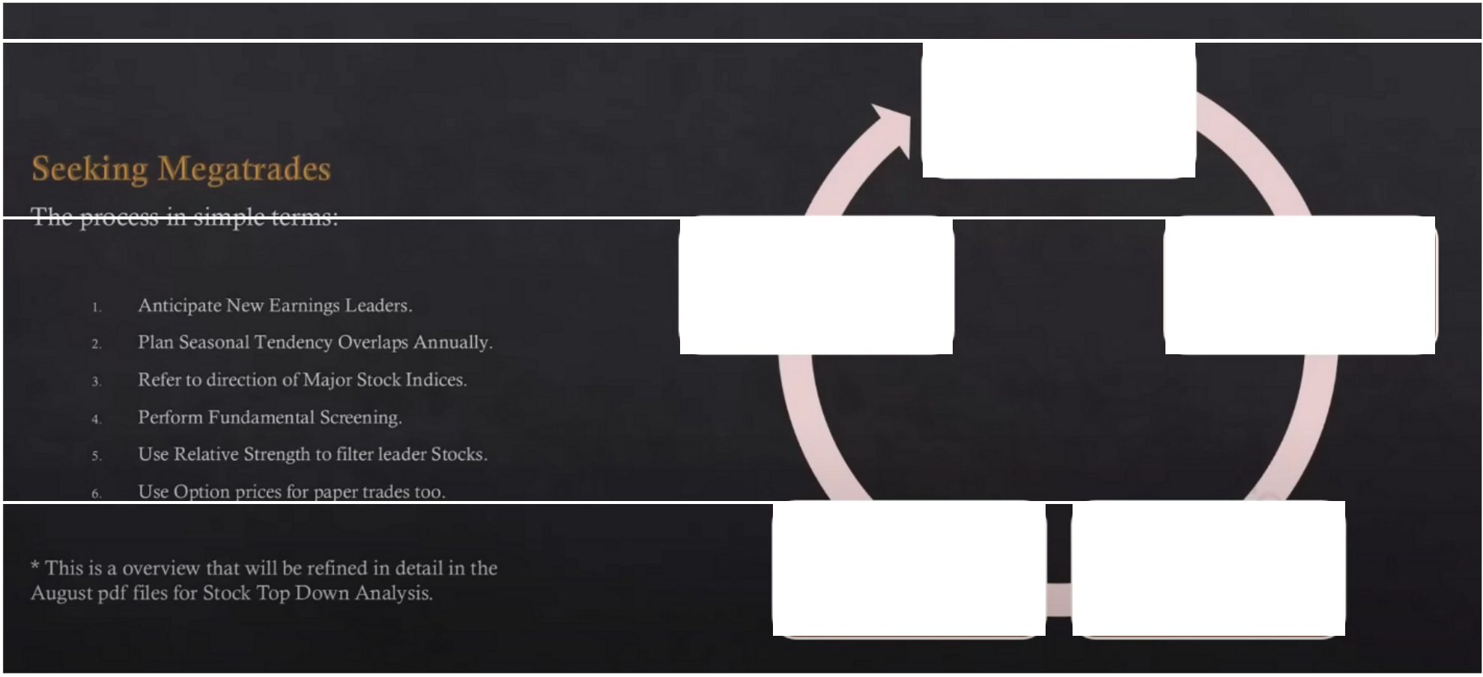

Seasonal Tendency

Fundamental

Screen

Major Market Direction

Strength

Relative

Quarterly

Earnings

1. Investors business daily for fundamentals, stocks that may tons and tons of money more then before
2. Again investors business daily

Relative strength is the best thing out there in ICTs opinion

**INVESTORS..** -

u-,--.-,_-,-.,,- -.,,-..,_......,..,....'°,.'."'_'_,,....,.. ...,_,_.,,_,..,. _-,-_,--._ ,

**Leaderboard·**

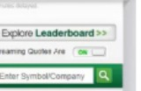

,,.,,., ...... ,u,o,, ···- ,..... _,...,_,. .. ,,..

_.. , ••• ♦-· ...... --· ... -·..... --· ...

**Leaderboard·**

These 4 IBD 50 Names Ride High In Earnings Season; Will Others Join?

07121'20110'24ill'MEl Jobuybelor•

.--.•,tp,(W.,l1,r<_nD11DlluV1TJW111'111

Wy,.,.,,_ AlolV­

kll)S IDlltoQl'WIOlmghl'Wll-lOl.lll'I

--

Frsl-klr-.dlonlcJ\aseeMOck""'•..wdld

_._!1,-.1poape,buyp(Nl'II lht$11X!t-bl'NpMl,ng­ OIC,,,...5".._. "&,,,-Nru,roo, Mllh-·

Two.cowcyour- lOClltlofhlnl-si.geDINkoul,U..-IIOW

-ISIOCl(-1I02"'.IOffl'lldll'IIWCUO.<IO!tiltbCIIOl"I ..

olM,_llt .....NIIOlll>w 500)el WIINda)'S l»SIOIOlllf'IYdlarlpatlitm -DIOl<t<Ueoa-'I W'lllllhlMMI

- -a _,_,.,.0.IO_,..M l'IIIS......Of....,,._lltfllOlt ,,.,"°'"'Sb:lt

- ..- ._ ,,, -on ,,_0. :1100'\ 0f"'°'tlro,,,U.,_.br9tikou!E-.4,_

--!)-,

,S.O_lorM,lli'°""".,. ,, IIOWOtsl<IO,O,,, hWMtf'l"'4oo«lt

_n..ts....., ol--CAHIUM1N1ffdi9,,l ,llll-bl' O,onttol,o'l6e8nt l'l•MI"'°''

Market In confirmed uptrend

S&P500mlkKnewh,gl\Nesdl,Qbcluncnlndlhl

runt.oldtll'ibllalm,1,_low

0TALaduutlonCllpAAOSITAL) IHS.73 -0.88 -o.sn, Volurne Chg _.5

IJPOATE007'21'201705 9PMET TAI.E lsui.--abrukout

-•---lagtlYM-al:M10burPOlflt.Tl,.HlQ:"1- .. lnell

- ,,..."'911 "' 01egiood"9' l{MOOl. ilhtW>Cl<"-mtOtlbog'IWI

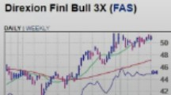

UPOIITEO OT?v.!011 0-01 PM fl Tho {lo"'"°" F_,.,.

ll,,,lt,l l&lnflll)'ra.not•-• ...IO -tl&l)lpolftl.l!lt.lti­

., ,_ID9"1"""' ThaETJ5111(119d■--•-IN-◄ ..0

o,J..,,.I O,v#IOl»""'•-..w....an_,,,.--, a« okwy Tl'ltITF•

IDdilO- l!,a-olb-... 1DOOf..-.c111- ,_ 1._..,..,,

..,.'ll_"!IUS ,IP9flol-•-.-.clh._tlecGkt

Netfllx, Vertex Move Solldly Higher; Trade Desk Lags

01/21'2017<M41PMET '"1111 (NASO,,\ONf"Ul)_V_,_,,,_..

T-C..,•oOOlll i,lrt•,_worlonOon1 .-ati

::::1ouypo,,,111'1,....bllcM-..- ""'71 ..,...

:::...-::.=:".:"'.."'"'o _..,

l VAn)lldh...,_r,,.,.,.-.

-...._ ,.(NASO,lll,OAMZN).,_,_._ ,gtl-1-

_,,:,n n.so.,,cl.. FlC ,_

---tlOl,Cftlll--.otflOIP.. -llfflll-t1 Cl pnc,non.-•)UM-1101960.,..,p(ll'WOIII

-

-tloJltalllOUQh»_._,.,

,_. ,_ n.daO.oll(NASDAOTID)_G,_.,

(NYSE_GAUB) ,_.1,w,ormo,111-t,t,,)lrnlld.._,.,.._,of

,e'\. 11""9111'1-porllCrldin.p,O"--.I....

-•· ..- R_.,..

Marht In confirmed uptrend

no.ml>ltof--0.,,S'-lbw

&P ---l'llgl'l

-­

Top 50 will give you a top 50 based on the fundamental rankings

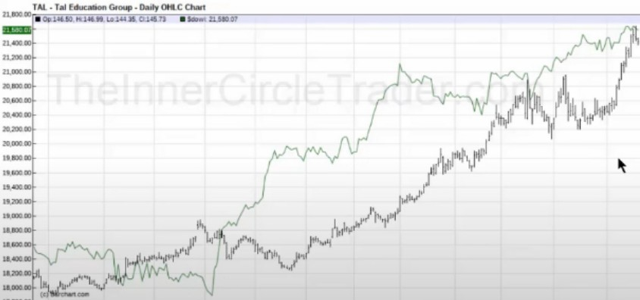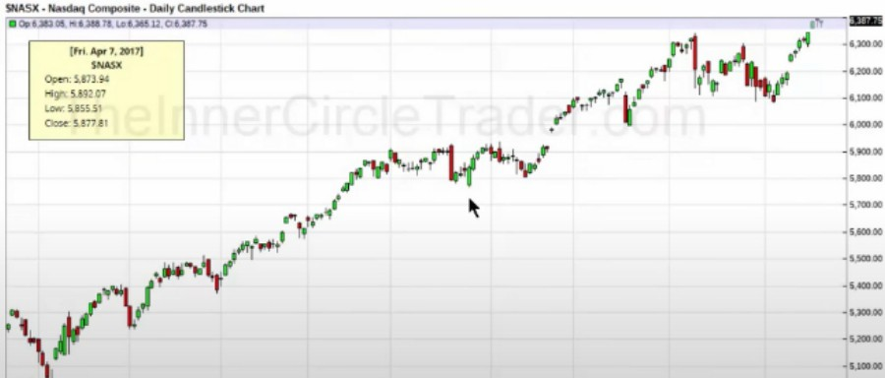

A phenomenal move, this works every single year

Once ICT has his watchlist he will go trough them everyday and just simply look for these divergences with an index at a time of the year where it should occur, in this case he used the DOW

Then filter out which are the strongest in their sector

Dow had SMT with Nas and SP also, NAS is filled with tech stocks so tech stocks are going to be strong

**2.1.80000** LITE· Lumentum Hid Cmn • Daily DHLC Chart

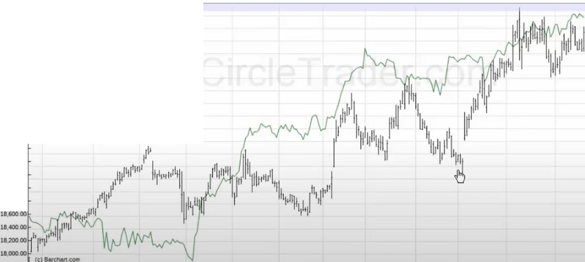

■ 0p 60 as ,. 64.25, Lo.eo.35, 0.63.35 ■SOow,. 21.sao.01

**21.400.00**

**2120000**

21.000.00

20,80000

2060000

**20,400.00**

2020000

2000000

1980000

**1960000**

**19 40000**

**1920000**

**19000.00**

1880000

(Mon. Moy 1, 2017)

UTE

Open: 43.10

High: 43.92

Low: 42.72

**Close. 43.70**

' '

1780000'

Auo 11 **Oct**

-

**De<**

**Jonl7**

-

6800

6800

**m**

**'2.00**

**6000**

**5800**

**56.00**

**5400**

**52.00**

**sooo**

**48.00**

**'600**

**4400**

**42.00**

**4000**

**3800**

**3500**

**3400**

**3200**

**lOOO**

**2800**

**Moy**

**Jun**

**2600**

Not a higher low, fundamentals fit the criteria but the technicals dont

-

**1.**

**NTRI** • **Nutnsystem Inc** • **Daily** OHLC Chart

**2 800** 00 ■ **Op 5a 40. tl..59.50, LD.57 00, 0.59.20** ■ **SOc,v.,t 21.580.07**

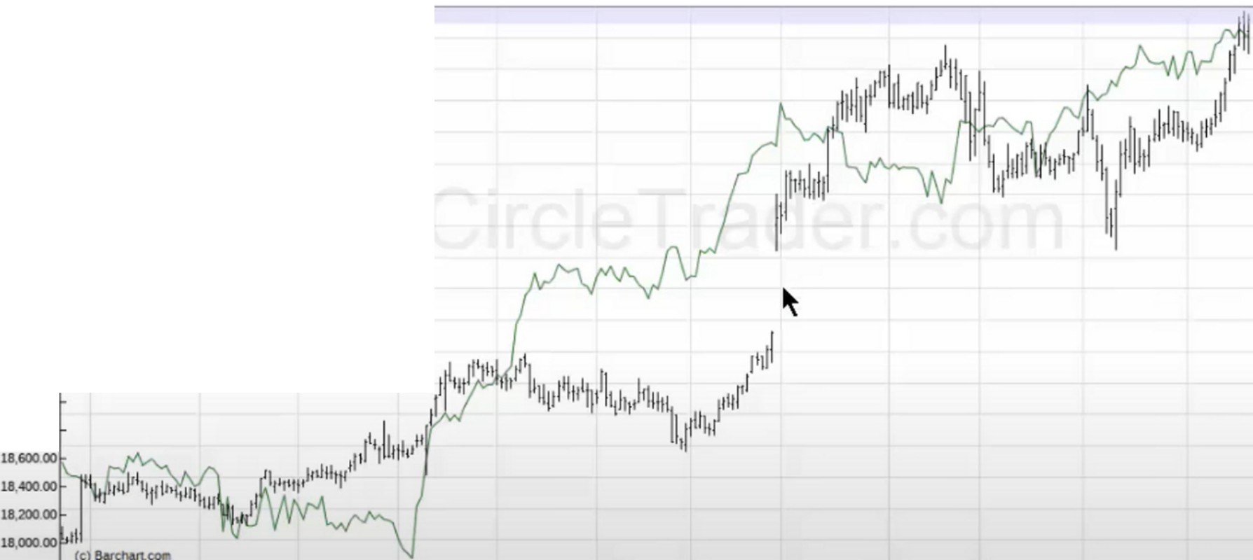

**!:IE.:D,, ------**

|  |  |
| --- | --- |
| **21.400.00** | (Wed. Mar 1, 2017) |
| **21.20000** | Open: 47.30 |
| **21.000.00** | High: 47.49 |
| **2080000** | Low: 45.55 |
| **20,60000** | **Close: 46.70**  **SDOWI** |
| **20,400.00** | **Close·**21.115.55 |

**NTRJ**

**20.20000r--------**

**20,000.00**

**19800.00**

**19,60000**

19,400.00

19,20000

**19,000.00**

1880000

- -

**58.00**

**5600**

**5400**

**52.00**

**5000**

**4800**

**'6.00**

**40.00**

**3800**

**3500**

**3400**

**:1200 lOOO 2800**

**2600**

**17tl0000 ------------------------ ----- 2400**

**AUQ 11 Sep Oct**

**De< Jonl7 fel>**

**Apr Moy Jun Jul**

We left a big gap, so even though we had SMT from an institutional standpoint it would be reasonable to expect us to trade to the gap. So this is not a good candidate because that gap could close, we want to look for a stock that has recently left a consolidation

ANET • Ansta Networks Inc • Daily DHLC Chan

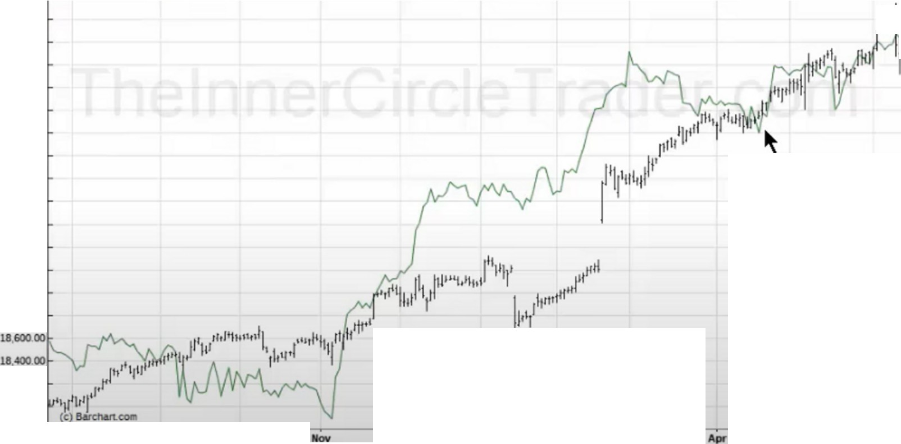

21,800 OO ■ Op.15LOO, !SA 00, Lo.149 00. al52.92 ■**Scio,-<** 21,5110 07

**21,40000**

**21.20000**

**21,000.00**

**20,80000**

**2060000**

**20,400.00**

**20.20000**

201XJCUJQ

**1980000**

1960000

19,400.00

**1920000**

19,000.00

**18,80000**

**18.20000**

-

1800000

**17.80000 Aug 16 Sep Oct Dec** .,.,. **17 Feb**

**Moy**

,,,,0

I 11'

**Jun Jul**

**16500**

**16000**

**111111**

I

**15000**

145.00

**14000**

**1.3500 lJ0.00 1.2500**

**120.00**

**woo uooo**

105.00

**10000**

**9500**

**9000**

**8500**

**8000**

**7500**

**71)00**

**6500**

This one is valid, even though we had the gap we consolidated after that and at the time of the SMT div

**Zl.800**

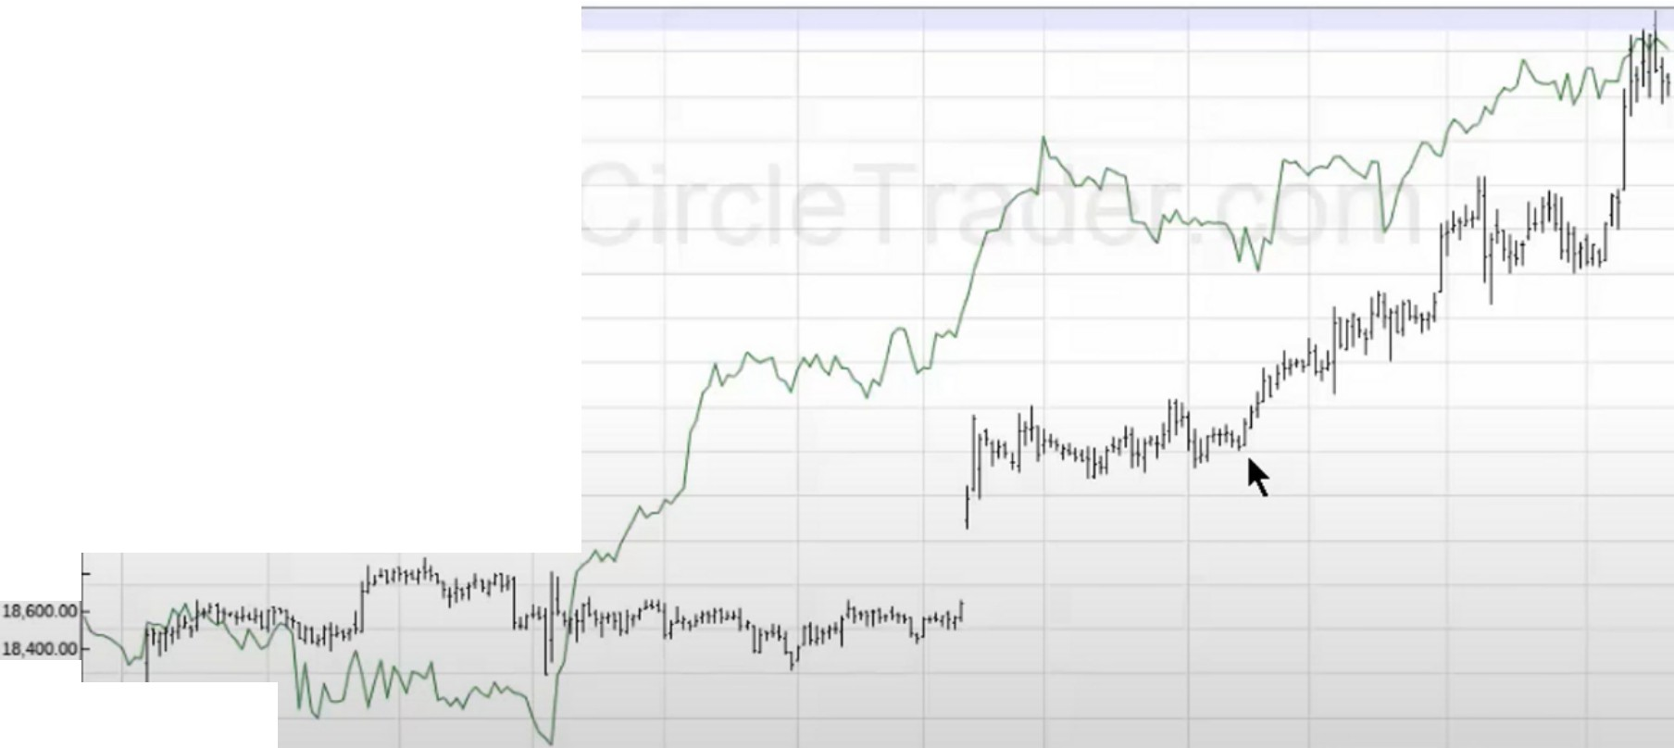

00 ■ **Op** 23.43 ,..23 **50,** Lo.23.C)2, azl.32 ■**S<low,** 21,580.07

21,400.00

2120000

21,000.00

CTRL • Control4 **Corpo<allon** • Daoly OHLC Chan

2500

2400

II!

2200

|  |  |  |
| --- | --- | --- |
| 20,80000 |  | 2LOO |
| 20,60000 |  | 2000 |
| 20,400.00 |  | 1900 |
| 20,20000 |  | 19.00 |
| 20000.00  19,80000 |  | 1700  1600 |

|  |  |  |  |  |  |  |  |
| --- | --- | --- | --- | --- | --- | --- | --- |
| UI 60000  19,400.00 |  |  |  |  |  |  | 1500 |
| 1920000 |  |  |  |  |  |  | 1400 |
| 19 000.00 |  |  |  |  |  |  | 1300 |
| 1880000 |  |  |  |  |  |  | 1200 |
|  |  |  |  |  |  |  | lLOO |
|  |  |  |  |  |  |  | **1000** |
| **1820000**  1800000 11/J"' t--  17BOO.OO  **Aug 16 Sep Oct** | **Dec** | **Jon 17** | **Feb** | - | **AP< Moy** | **Jun** | **900**  **----- 800**  **Jul** |

Only reason ICT doesnt like this is because its below 20 dollars a share, he wants stocks above 20 dollars a share preferably 25

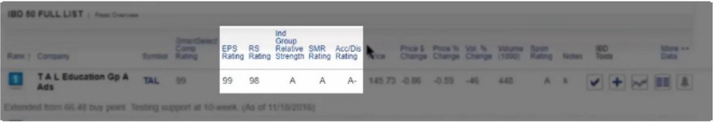ICT likes this smartselect comp rating, he wants 98 or higher



c-_ ... ...,..,.... ---,-'a1_,. IAl,.,,.1&'201't

0 --..., u11 • ,. a-U:15 2110 oo 11 .;+p,,,<11•

1. OIUTIIIIUTUIINC HTIII tf

c--- :,:,10Dolj>"poo'II•• ·- 1"'11101714011►

D ·- l,.COllllNC tlW tf A• A II, 1091:10.00 Ol/ .,0 251 

F.,._ollO--.-e,--- iAUIO/'ll 2011

.....

a AlltUO-tllle AHif 911 A 15.2112 -3N -HI U .,,.



D COH&flPTINC • ano -111 -(I• *�1* ,),Q 1 .; + p,,,< 11 .f.

**l FOXF** · **Fox Factory Cp** Cmn • **Daily OHLC Chatt**

**2 800**00 ■ **0o 37.95 *,._31* 95. Lo.37 30, Ctl1.&o** ■ **SOow, useo.01**

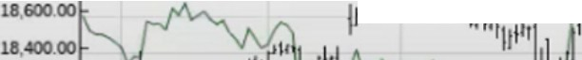

1,11 1,111, I

**18200**

**UIOOOOO**

**neoooo ' - ---------**

**Auoa**

Sell

OCI

-

I

|  |  |
| --- | --- |
|  |  |
| **U«J0.00** | **[Mon. May 8, 2017]** |
| **2U0000** | **FOXF**  Open: 31.45 |
| **uooo.oo** | High: 32.50 |
| **2080000** | Low: 31.25 |
| **2060000** | **Close: 31.80** |
| **20,400.00** |  |
| **20.20000** |
| **20.000.00** |
| **1980000** |
| **1160000** |
| **l9,«JO.OO** |
| **19 20000** |
| **19000.00** |
| **ta80000** |

i'h I

3900

**illlS**

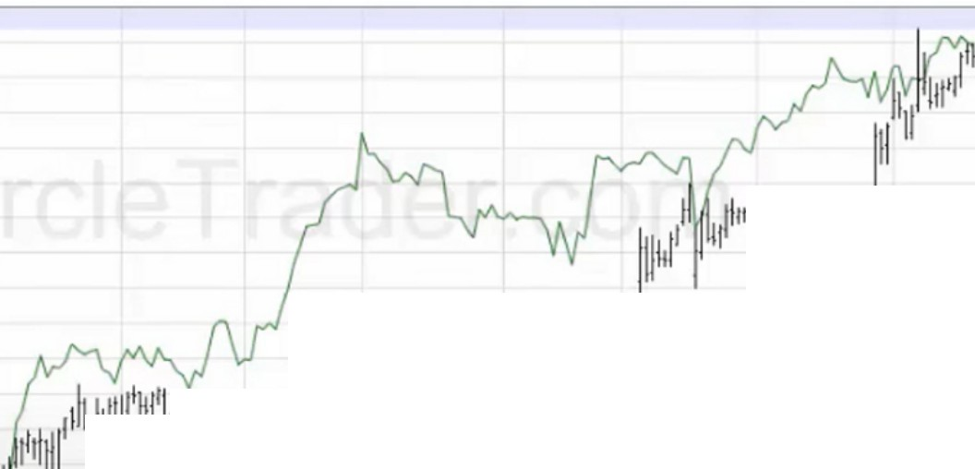

't,111"',,!11/

111 11

I

11111!11

''"'11

I i1l1111,11il'" If 11'!'11I linl

11 11 I 11,1 "'1 "'

11,

**3700**

**3600**

**3600**

**.. oo**

::

**2100**

30 00

2800

::

I **2500**

***..A***

**2,00**

fl11 2300

22.00

**21.00**

**2000**

-

**------------------**

**1900**

**iaoo**

Not a huge amount of movement but not bad, its like a 50% return

Dec Jonl7 Feb

**Apr Moy** Jun Jul

2l.800

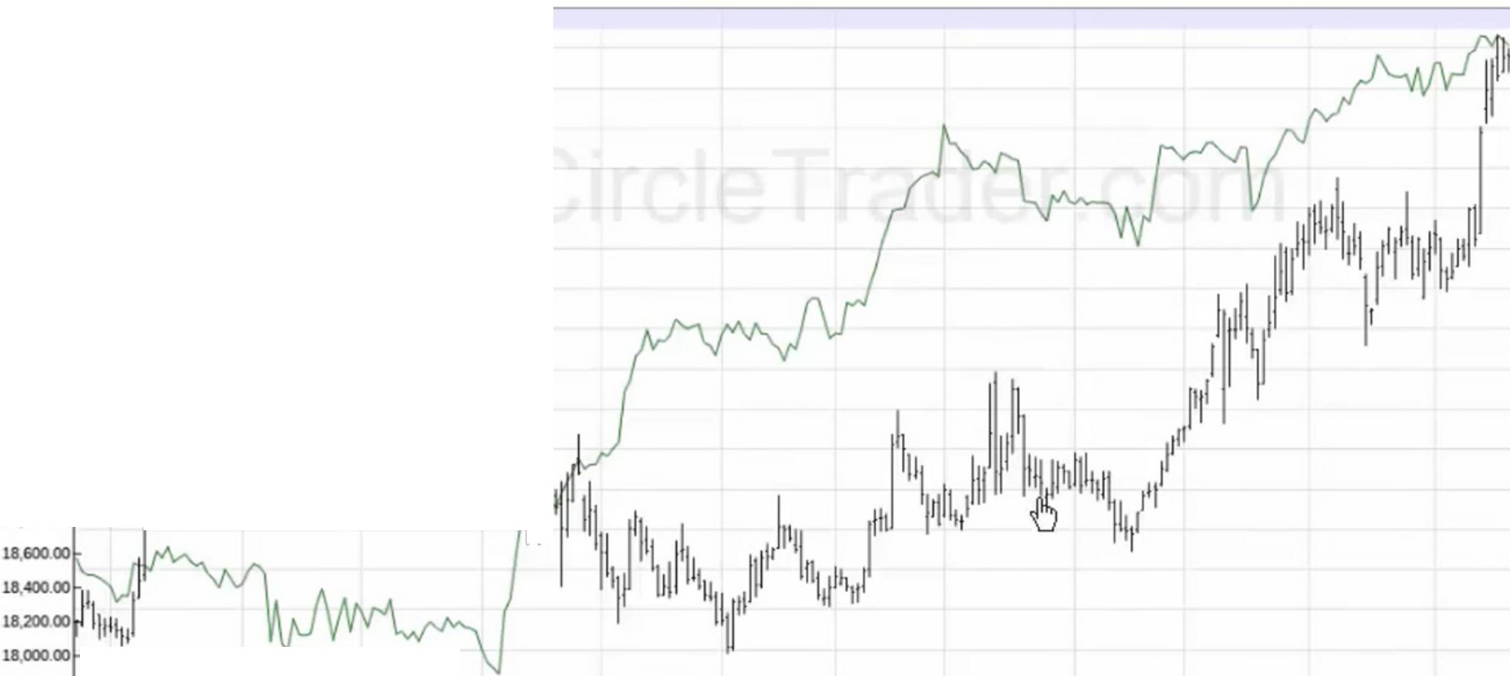

YY • YY Inc • Daily OHLC Chart

00 ■Oo.67 69 .67 93, Lo.66.80, Cl67 59 ■Sc1ow,: 2l5eo 07

7000

**!lmilili, ----**

2l«J0.00

2l20000

21.000.00

2080000

**20,60000**

(Mon. Mar 13. 2017]

yy

Open: 47.tl Hig : St.25 Low: 47.08

Close. 48.80

SOOWI

66.00

6400

'2.00

6000

5800

-C-lose· 20l_1•M_iii111-ll11ll/1l'l111111ii1'1,I

*i*IIiliii, lli'1

I i'

1880000 I

- -

56.00

5400

52.00

5000

4600

44.00

42.00

,000

**l800**

**(c)8«d\ln.coa**

**17,80000........... 3600**

**Aug 16** Sell OCI

Invalid, we made a lower low

Dec

- l7

Feb

**Apr** May Jun Jul

MASI • Masomo Co,poratoon • Daily OHLC Chan

21.90000 ■ 0!> 97 78 ,. _9=779 , Lo-.96=oL tt=96 19 . - -, 21. sao=01 ---------------------=11 10600

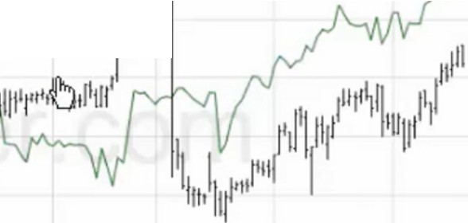

I I

11'

I

I

m.:ililii1, ,

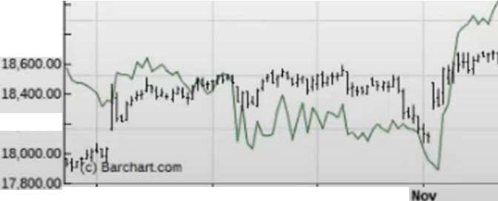

21.«JO.OO

2120000

21.000.00

**2090000**

2060000

20,400.00

(Wed. Apr S, 2017!

MASI

Open:93.93 igh: 94.70

Low: 92.88

Close· 92.97

SDOWI

Close· 20,648.15

20 20000t<---------

20CXIO.OO

1990000

1960000 l9,«l0.00 1920000

19,000.00

18,80000

**18 20000**

**Auv 11**

**Sep**

**0a**

,,

I

If

**10000**

**m**

**9000**

**8500**

1,tt.'1,1)1•1

,111111

* ''''"'''

**Dec**

i'' 111

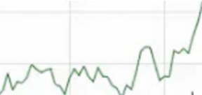11'

,,111•lh11•111

I

**11000**

**7500**

**7000**

**6500**

**6000**

**5500**



**Feb**

-

**Moy**

**Jun**

**- sooo**

**Jul**

Already extended a lot, very suspect

**INVESTORS....,",""""'"OY"""'rn>O•- .........**

S&P soo• 2,472.42 OJIA• 21,578.15 NYSE VOLC-I 2,93-4 NASDAQ 6,387.75 NASOA.QVOL!Yll) 1,763

-0.04¥. ♦ -1.03 ♦ -{1.16% ♦ -33.63 ♦ -3.95.,.♦ -120. -0.0-4% • -2.25 ♦ -2.08% ♦ -37 •

* **Explo<e Leaderboard** »

Slreams,g Ouoles Ase a..

0 ABOUT Enter Symbol/Company •



**Should Arista Shareholders Be Worried About Cisco-Related ITC Ruling?**

Updated 07121/2017 02.42 PM ET I Sellers were in **Arista Networks (ANET)** Friday after the US lntemallonal Trade Commossoon (ITC) denied a request by the company to loft a ban on imports of some of ,ts products related to a patent dispute woth **Cisco Systems (CSCO)**

The US. Patent and Trademark Office recently ruled that the two Cosco patents in question are invalid.

Arista sells network switches that speed up communication among racks of computers servers on data centers

A couple of former high-profile Cisco executives are now on charge at Arista, 1ncludong CEO Jayshree Ullal and co-founder, chairman and chief development officer Andy Bechtolsheom.

The patent dispute started in 2014, but ot hasn't impeded Arista's price performance much Year-to-date, shares are up 58% compared to a gaon of around 10% for the S&P 500 . **Read more**

**Market in confirmed uptrend**

S&P 500 makes new high, Nasdaq bounces and the number of dostributoon days remains low.

$79.45 -0.90 **-1.12%** Volume Chg. -56%

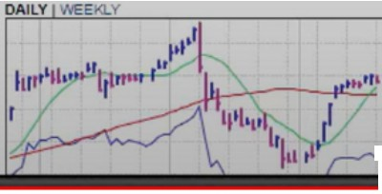

IBD Sector Le.sders I RMd 0--

fJ Chips

**M K s Instruments Inc (MKSI)**

85

**80**

75

03 70

UPDATED 0712112017 06 25 PM ET I MKS Instruments 1s **forming a third-stage, cup-shaped base with an 88.60 buy point.** After a 25% pullback MKS Jumped back above ,ts 10-week moving average 1n the latest week. strengthening ,ts technical picture The current base features three big down weeks on very heavy turnover but notice how the stock got support at the key 40-week lone **Backstory** The company

Research

Tools

.,

+

IBD sector leaders is another one, these are the leaders of their respective sectors

Let IBD do the number stuff for you and let us look at the techicals

Just because its on the list doesnt mean its going to perform, they do the fundamentals and we do the technicals

The best and strongest thing in trading in ICTs opinion is the SMT relative strength divergence seen

in stocks against the major indices, its easy to see the high flyers

**MENU** ::'-: **GUIDE.com STOCK RESEARCH NEWS GLOSSARY** -

Stock > Sta :k L ,t > Sectors

**List of Major Stock Market Sectors**

**Basic Materials Industrial Goods**

**Conglomerates Property**

**Consumer Goods Services**

**Financial Technology**

**Health Utilities**

**Healthcare**

I **STOCKS**

**Browse by Sector Browse by Industry Browse by Letter**

lnvestorguide.com

All the stocks in the individual sector

telecharts, a guy used that for relative strength analysis which was interesting

SMT is the silver bullet and you have to know WHEN the market is going to move and then when theres a little crack between the indices in the form of SMT on the daily chart thats when this is golden

Look for buys primarily, you have to know what youre doing to short stocks, shorting is going to be smaller moves most of the times very abrupt. Banks will put more money in the stocks when buying and the selling will be short

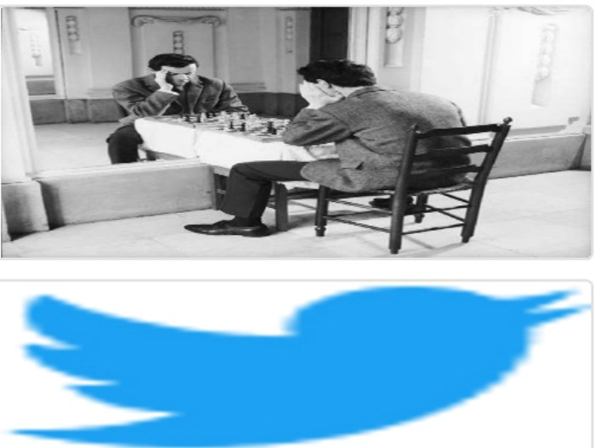Arjo I Twitter, lnstagram I Linktree

Linktree. Make your link do more.

I https://1.co/HhmmTN1fUI

JavaScript is not available.

*"!I* https://twitter.com/arjoio